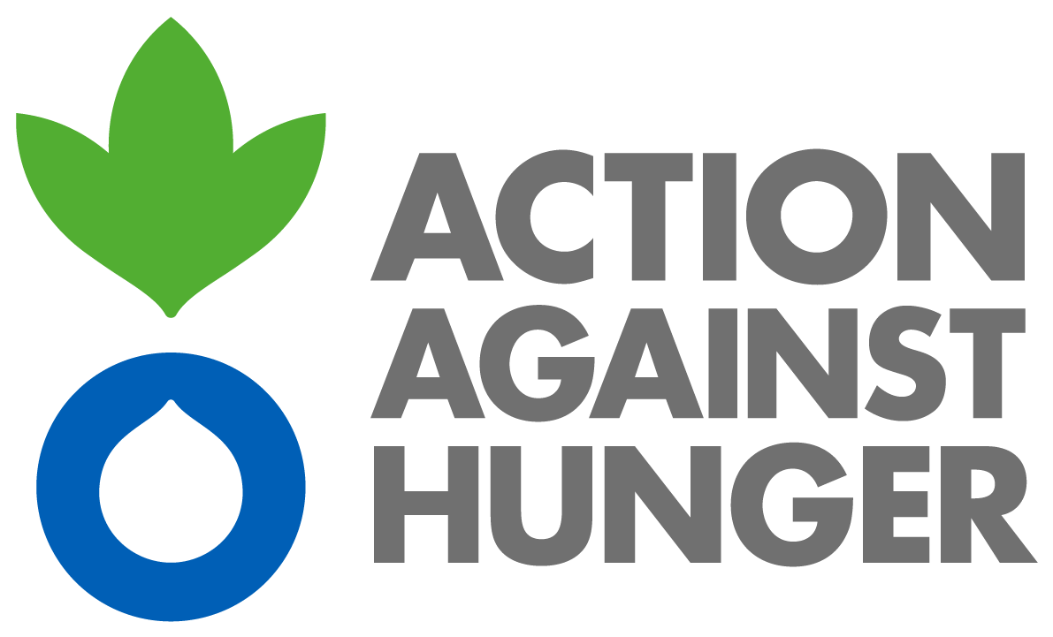

Action Against Hunger

Philippine Mission

|  |
| --- |
| **ADVERTISEMENT** |

**Call for Tender**

Action Against Hunger is an international, independent humanitarian organization that aims to fight hunger in all its stages. It has been implementing several emergency responses and developmental program focusing in Health and Nutrition, Water, Sanitation and Hygiene (WaSH), Food Security and Livelihood (FSL), Disaster Risk Reduction (DRR), Good Governance and Advocacy since 2000 here in the Philippines

Action Against Hunger intends to establish framework agreement and inviting to submission of tenders for the following service:

**Reference No: PH/ML/07148**

**Description: Service Framework Agreement for Vehicle Rental**

Detailed technical specifications are included within the tender documents which can be collected from Action Against Hunger Office between 10am to 4pm at the address given below or by contacting the tender committee all in copy at following e-mail address:

* [jlaguidao@ph.acfspain.org](mailto:jlaguidao@ph.acfspain.org)
* [ralvarez@ph.acfspain.org](mailto:ralvarez@ph.acfspain.org)
* [msuarez@ph.acfspain.org](mailto:msuarez@ph.acfspain.org)

**Acción contra el Hambre | Action Against Hunger**

4rth Floor, Eurovilla 4 Building, 853 A. Arnaiz St. Legaspi Village

Makati City Philippines 1229

Action Against Hunger does not bind itself to award the tender to the lowest tender or any bid and reserves the right to accept the whole or part of the tender.

The deadline for submission of tenders is on **10-August-2018**