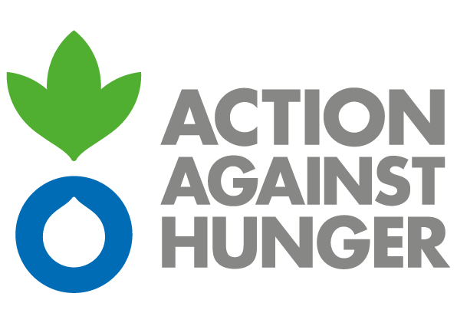 | Action Against Hunger  Mission South Caucasus

ADVERTISEMENT

Contract title: Procurement of Agricultural Items for GED1AW “Strengthening self-reliance and agricultural livelihoods of vulnerable groups in Eastern Abkhazia”

Action Against Hunger tackles the causes and effects of hunger and diseases that threaten the lives of vulnerable children, women and men.
Established in France in 1979, Action Against Hunger are a nongovernmental, non-political, non-religious, non-profit organisation.

Action Against Hunger – South Caucasus intends to award a Framework Agreement for the supply of items detailed in Annex I in the framework of humanitarian programs funded by UNHCR.

Bidding documents can be obtained by interested parties through submitting the request on following email address: procurement@sc.acfspain.org

Action Against Hunger does not bind itself to award the tender to the lowest tender or any bid and reserves the right to accept the whole or part of the tender.

The deadline for submission of tenders is 5th July at 5 p.m. Madrid time.

